Experiment

**Premise**

* Subjects will lay in the fMRI scanner and drink either appetitive or aversive juice. They will be cued before juice consumption about the probability of receiving the appetitive juice. Sometimes this information will be updated once more before consumption.

**Player**

* Just lays there and drinks.

**Environment**

* A PsychoPy experiment in the scanner. A tube will run from juice press to subject’s mouth.

**Experiment**

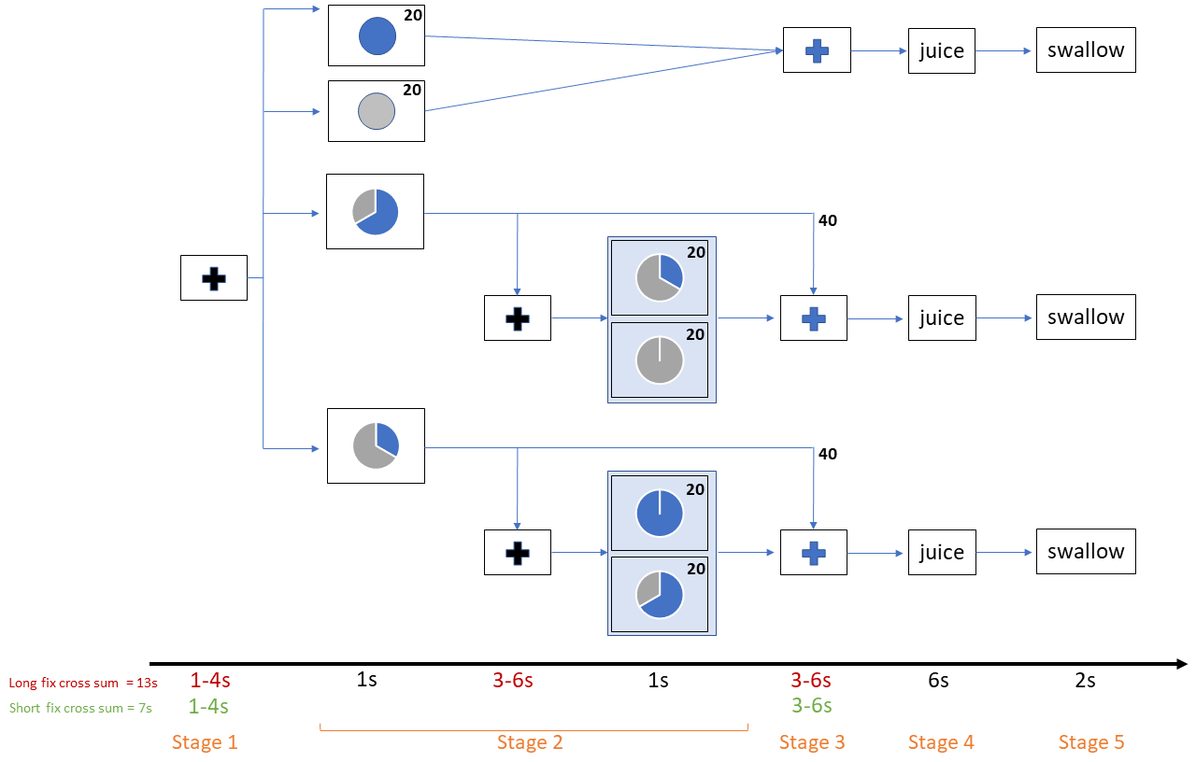

Pre-Experiment

* Appetitive juice is selected prior to experiment by liking rating task (0 to 5). Aversive juice is a saline solution made of the ionic components of saliva.
* Instructional period with 10 practice trials on laptop, no juice.

Stage 1

* Subjects fixate on a black fixation cross for 1-4s, jittered according to a pre-determined trial duration.

Stage 2.1

* A pie chart is presented with the probability of appetitive juice.
* If this is a trial where information is updated, then continue with Stage 2.
* Otherwise, skip to stage 3.

Stage 2.2

* A black fixation cross is presented for 3-6 s, jittered according to a pre-determined trial duration. Black indicates that the next screen will display a new pie chart. The new pie chart is the new probability, and subjects will be instructed that they should completely update their beliefs.

Stage 2.3

* A new pie chart is presented with the probability of appetitive juice.

Stage 3

* A blue fixation cross is presented for 3-6 s, jittered according to a pre-determined trial duration. The blue color indicates to the subject that they will receive juice on the next screen.

Stage 4

* The screen will present a stimulus for appetitive or aversive liquid. Liquid will be injected into subject’s mouth. Subject holds the juice in their mouth for 6 s.

Stage 5

* The screen will display instructions to swallow for 2 s.

There are 8 conditions:

1. Certain appetitive.
2. Certain aversive.
3. Likely appetitive.
4. Likely appetitive, update unlikely appetitive.
5. Likely appetitive, update certain aversive.
6. Unlikely appetitive.
7. Unlikely appetitive, update certain appetitive.
8. Unlikely appetitive, update likely appetitive.

Conditions (1,2,4,5,7,8) have 20 trials each. Conditions (3,6) have 40 trials each. Total of 200 trials, split into 4 blocks of 50 trials each. Each block will have 5 trials from conditions (1,2,4,5,7,8) and 10 trials from conditions (3,6), randomly ordered.

Trials without updating (conditions 1,2,3,6) are shorter trials. Fixation cross durations will adjust so that these trials last 15 s.

Trials with updating (conditions 4,5,7,8) are longer trials. Fixation cross durations will adjust so that they last 23 s.

This means each block will last 13 m 55 s. 4 blocks totals 55 m 40 s of task time.

I estimate roughly 10 minutes for appetitive juice selection, 15 minutes of cumulative instruction period before the experiment, and 10 minutes of cumulative break time between blocks.

This totals 35 minutes of non-task time, for a total 1 h 30 m 40 s of scanner time per subject.

I can book the scanner room for two, 1 h sessions per subject. I plan to pay subjects $30 for the first session and $40 for the second session (2 h * $35 per hour, split in a way that incentivizes return).

**Analysis**

Why these 8 conditions?

The certainly appetitive and aversive conditions (1,2) give us baseline levels of OFC activity to compare uncertain trials to.

Likely and unlikely appetitive (3,6) give us low and high surprise utility trials. Comparing these trials, along with the certain trials, gives us tests of KR preferences.

The updating conditions allow us to test for RPE signals in the OFC. The goal is that we find separate areas that encode RPE and value. Updates that result in certainty (5,7) are meant to test of large changes in probability of reward. Updates that just change the relative amount of uncertainty (4,8) are meant to test small changes in probability. We can compare change in activity between (5,7) and (4,8) to see if potential RPE signals are actually scaling with the amount of change (i.e. if they’re actually RPE signals).

We can further verify RPE signals by looking at direction of change. Conditions (4,5) are meant to elicit negative RPE, while (7,8) are meant to be positive.

**Recording** **data**

* Generate a file that keeps track of:
  + Subject ID
  + Session
  + Block
  + Trial
  + Trial onset (using a timer that starts at the beginning of the block)
  + ITI duration
  + Pie chart 1 duration
  + If update occurs,
    - Fixation cross (for update) duration
    - Pie chart 2 duration
  + Fixation cross (to signal incoming juice/no juice screen) duration
  + Probability in first pie chart
  + Probability in second pie chart
  + Outcome
  + Juice screen duration
  + Swallow screen duration
  + Whole brain BOLD activity (which I believe will record one long dataset for each block)

**Interfacing with other hardware**

* PsychoPy needs to interface with juice pumps and the fMRI scanner.
  + Scanner sends input “5” when it starts scanning. Use this to begin experiment. And implement lots of experimenter-controlled checks/stops.
  + Not sure how juice pumps work yet.